How Students Find Badge Fee Amounts In Destiny
These instructions are for student logins only.
Using a CFISD Chromebook, follow the instructions below:
- Students must use CFISD Google username email and password to log into the CFISD Chromebook. Then, the student must use s# and password to log into the student CFISD portal.
2. Then, click on Library Resources
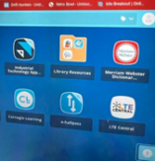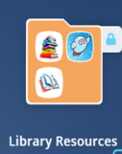

3. Next, click on Destiny Library
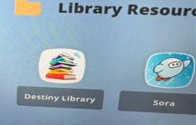

4. In Destiny, click on My Stuff
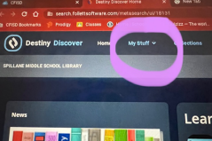
5. Under My Stuff, go to Fines
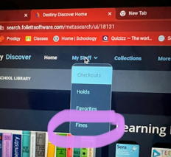

6. Under Fines, you will see individual badge fees.
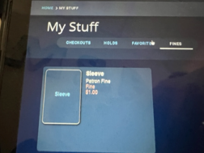

How do I pay my Badge Fees?
- Pay your badge fees on Schoolcash Online

